

**METU**

**ELECTRICAL AND ELECTRONICS ENGINEERING DEPARTMENT**

**EE463 – Static Power Conversion I**

**Fall 2021-2022**

**Term Project Simulation Report**

**Judicator Inc.**

**Hüsnü Oğuz YORGANCILAR**  **2305787**

**Ece İrem YAZIR**  **2376101**

**Kaan TÜTEK** **2375954**

**To be submitted to: Assoc. Prof. Ozan KEYSAN**

Table of Contents

Introduction 3

Topology Discussion 3

Simulations 4

Rectifier 4

Buck Converter 4

555 Timer 12

Overall Circuit 14

Component Selection 15

Thermal Analysis 16

Implementation 16

References 16

# Introduction

# In this report, the simulation results and comments will be explained about the AC-DC converter hardware project. The comparisons and properties about rectifier topology will be shown and simulation results for the chosen topology will be shared. Component selections based on these simulations are explained with the thermal situation of the system that will be used. Finally, the status about implementation of the project is shared.

# Topology Discussion

|  |  |  |  |  |
| --- | --- | --- | --- | --- |
|  | Vout | Vripple | Number of elements | THD (in the ideal case) |
| 3PCR | Vph,rms cosα | Vll (1+sinα) | 6 Thyristors + Elements for gate driving + Other passive elements | 31.08% |
| SPCR | Vs cosα | Vs (1+sinα) | 4 Thyristors + Elements for gate driving + Other passive elements | 48.43% |
| 3PDR | Vph,rms | (1-) VPH,RMS | 6 Diodes + Other passive elements | 30.27% |
| SPDR | Vs | Vs | 4 Diodes + Other passive elements | 48.43% |

Table 1. Topology Comparisons.

The ac-to-dc conversion can be done via four different circuit topologies listed in the above table. In order to have a better signal at the rectifier output, lower ripple voltage is required, so single phase choices are eliminated. Also, comparing the harmonics, we can say that filtering a three-phase source would be a lot easier. For these main reasons, we decided to choose a three-phase rectifier. When it comes to the comparison between a thyristor and a diode topology, we decided to use a diode rectifier since the main problem was to implement many more components for thyristors’ gate drivers. Also, the diode topology was cheaper even with a buck converter than the thyristors and gate driving circuits.

# Simulations

## Rectifier

In this project, it is required to obtain maximum output voltage as 180V. The duty cycle is recommended to be in between 0.2 and 0.8. If it is taken as D= 0.8, required phase voltage rms for three-phase diode rectifier can be calculated as follows:

🡪

Diode forward voltage is taken as 1.46V according to the datasheet of the subsequently chosen diode DSEP30-04A. Hence, is chosen as 100V considering the non-idealities such as diode forward voltage, and the simulation is performed accordingly. Voltage and current graphs of input, output and rectifier diode are obtained for the circuit in Figure X with resistive load R=10Ω.

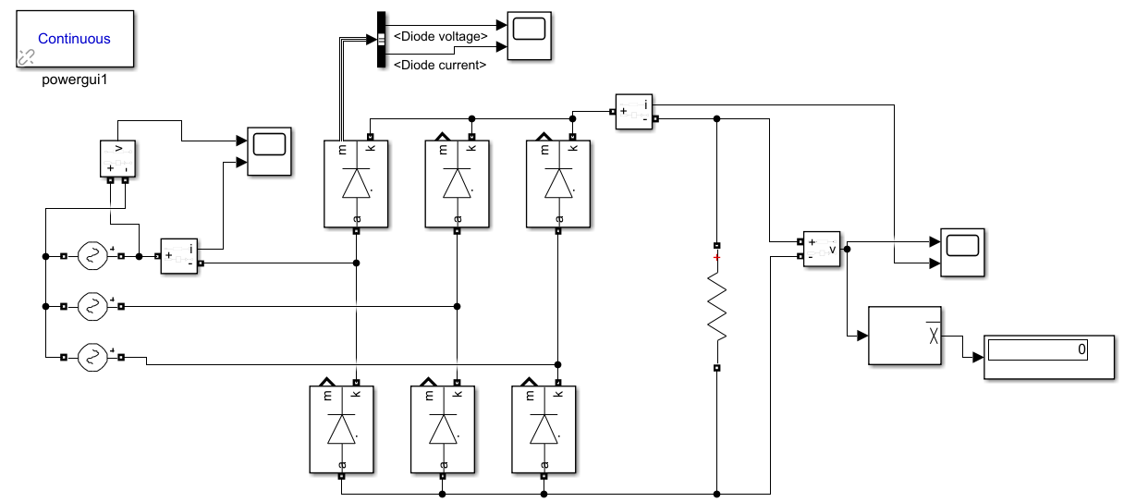

Figure 1. Three-phase full bridge diode rectifier model in Simulink.

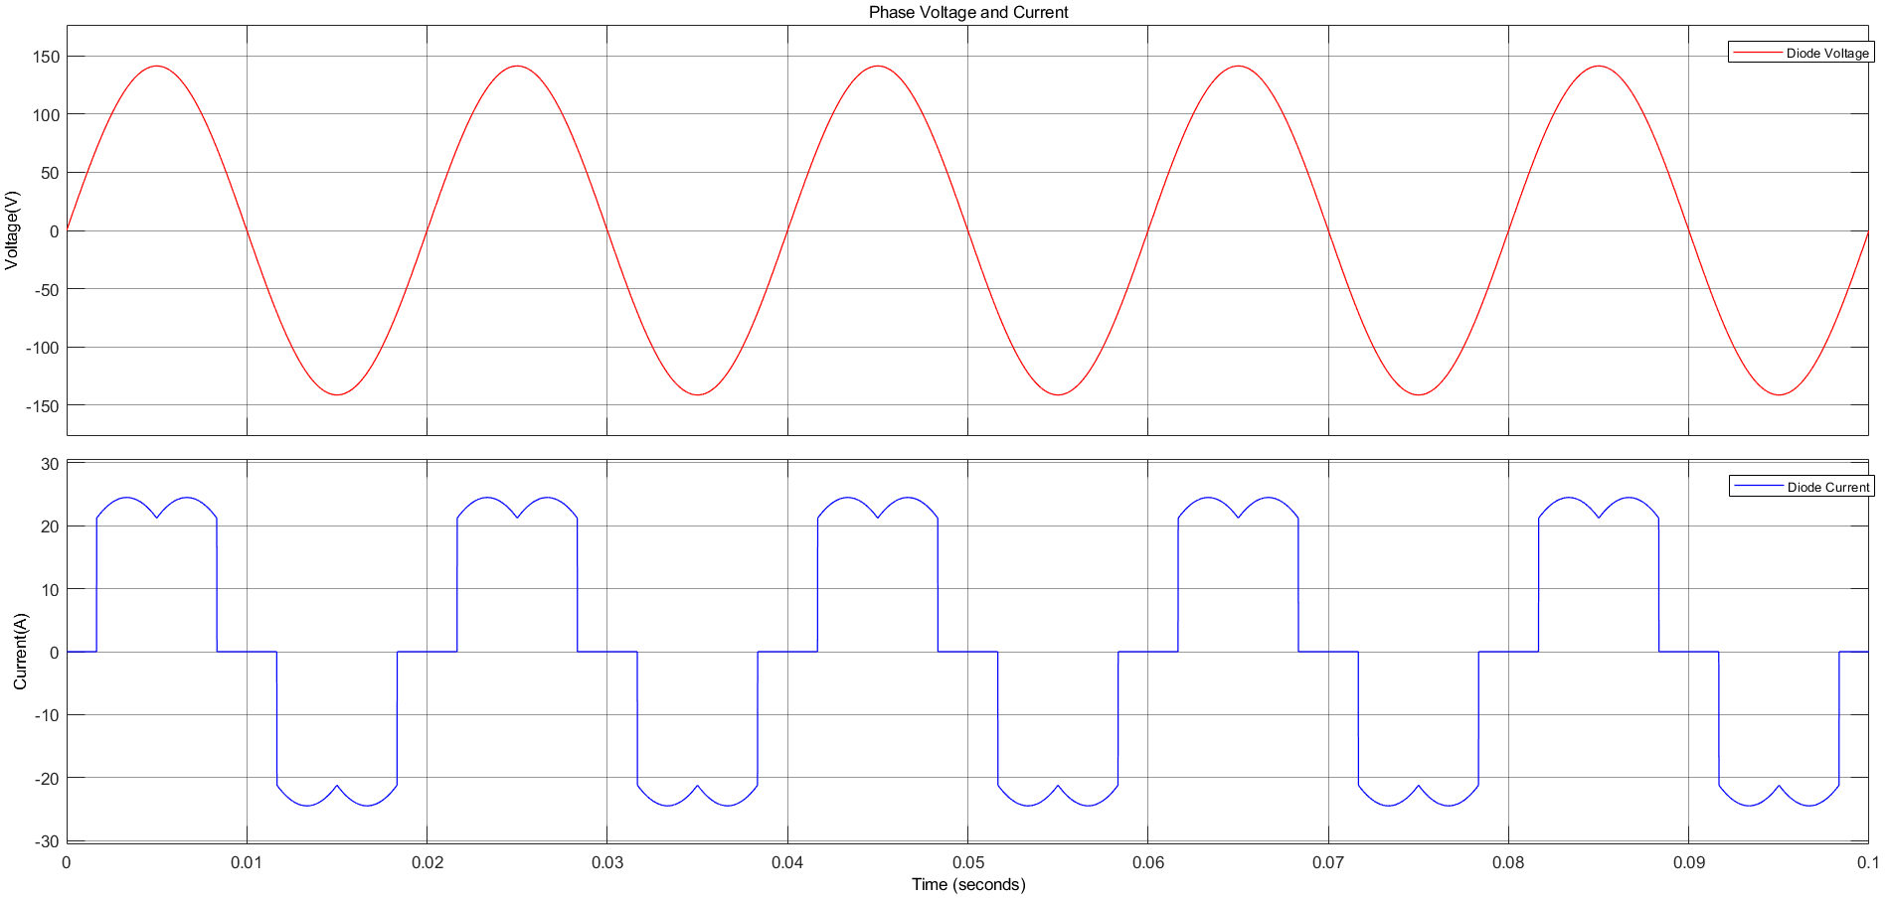

Figure 2. Phase voltage and current waveforms of the rectifier in Simulink.

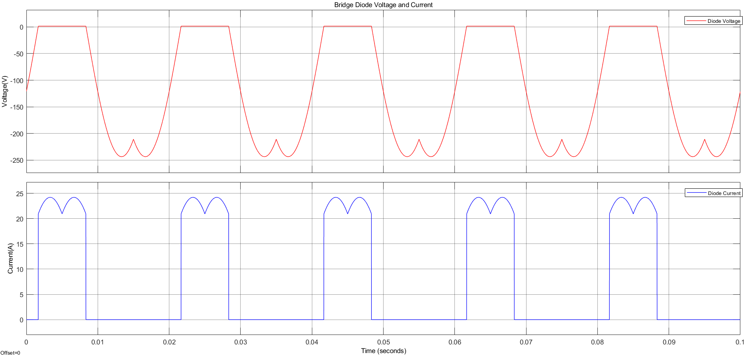

Figure 3. Diode voltage and current waveforms of the rectifier in Simulink.

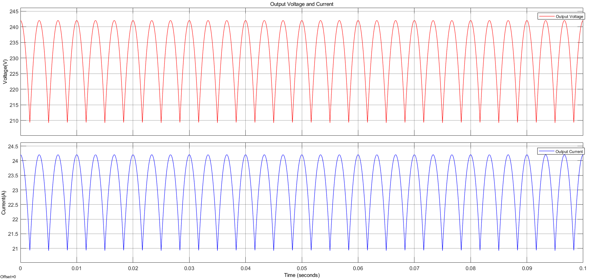

Figure 4. Output voltage and current waveforms of the rectifier in Simulink.

After these, rectifier stage is simulated with line inductance, line resistance, and DC link capacitor. DC link capacitor value was expected to be in the range of 100µF-1000µF. By simulating for selected values which are chosen considering the capacitance values in the market, 470µF is found adequate which gives around 4% output voltage ripple. Also, ESR of the capacitor is included where subsequently selected capacitor has 0.423Ω ESR.

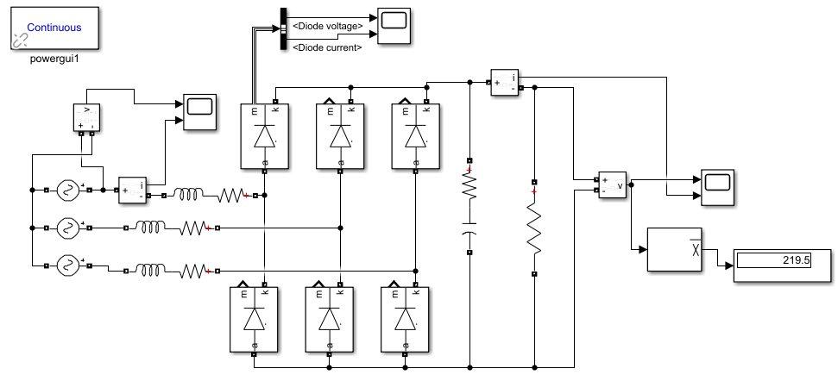

Figure 5. Three-phase full bridge diode rectifier with DC link capacitor model in Simulink.

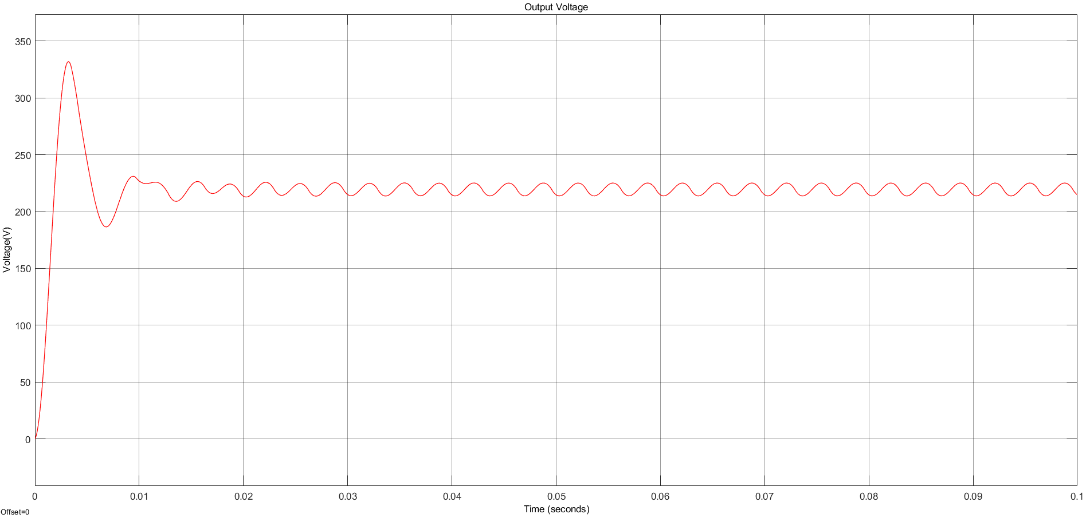

Figure 6. Output voltage waveform of the rectifier with DC link capacitor in Simulink.

## Buck Converter

With the output of the rectifier fed into the buck converter and the output of the rectifier fed into the DC motor with a terminal voltage limit of 180VDC, the relation between the buck converter input and output demands a careful cap on its main control parameter, the duty cycle. Vs,rms will be assigned 100V as was done in the rectifier simulation.

However, with the addition of an output capacitor, the average output voltage of the rectifier is expected to increase. This increase can be compensated by decreasing the calculated duty cycle. For now, we will limit D at 0.7. This will be monitored with the potentiometers inside the 555 Timer topology.

Even so, a duty cycle of 70% could be fatal to the driver circuit during start-up. DC motors have large inrush currents due to the induced emf being speed dependent:

The low speed of the motor, coupled with the low armature resistance of 0.8Ω, can lead to very high currents. Considering we are allowed to soft-start the motor by manipulating D over time, we will start the circuit with a 10% duty cycle and measure the voltage and current maxima displayed over the components. This will help us simulate the worst-case scenario in terms of currents and determine the limiting metrics. We will replicate the DC motor as an RL branch in series with Ea=0.05V.

The buck converter won’t have an LC filter at its output due to the motor acting as an RL load itself. The switching component was selected to be an IGBT due to its superior current-voltage limits. The input was provided as 220VDC.

The frequency of operation was registered in the pulse generator block as 1kHz. The pulse generator represents the 555 Timer output.

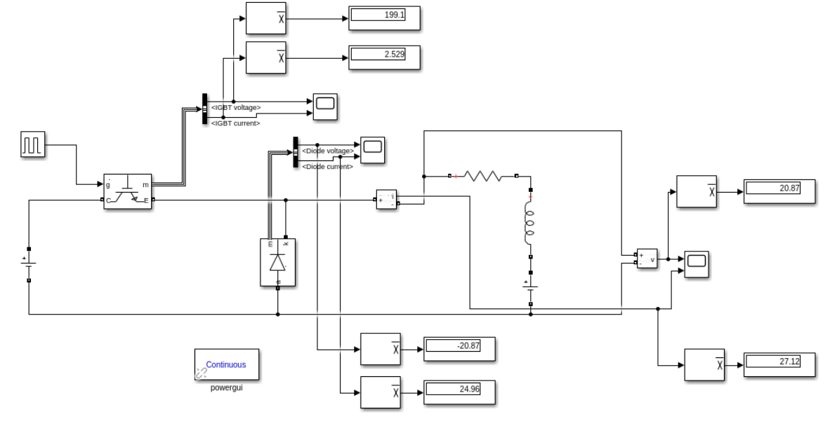

Figure 7. Standalone buck converter model at D=0.1 in Simulink.

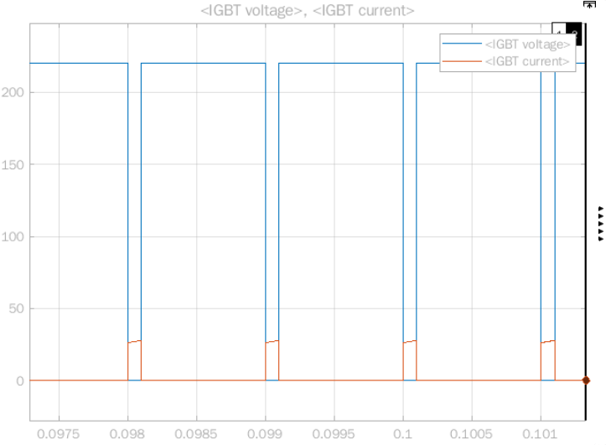

Figure 8. IGBT voltage and current waveforms at D=0.1 in Simulink.

An average voltage of 199.1V and an average current of 2.529A was recorded on the IGBT for D=0.1. Considering Vin * (1-D) is 198V for this duty cycle, the IGBT diode voltage is a value we were expecting. This is because the IGBT voltage is zero during the on period (for an interval of DTs) of the buck converter, and nonzero otherwise.

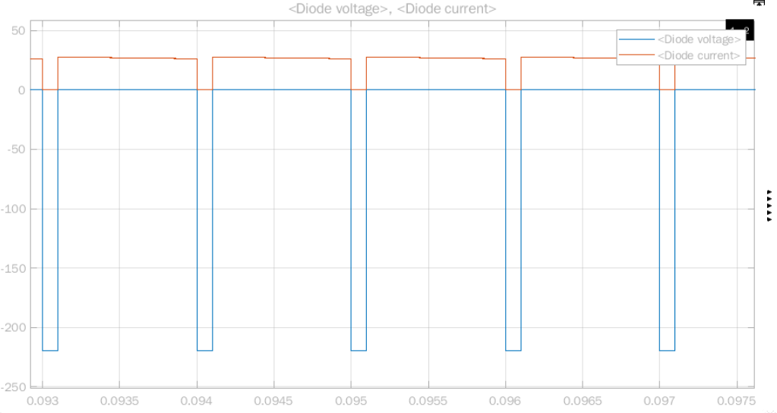

Figure 9. Freewheeling diode voltage and current waveforms at D=0.1 in Simulink.

An average voltage of -20.87V and an average current of 24.96A was recorded on the freewheeling diode for D=0.1. Considering Vin * D is 22V for this duty cycle, the average diode voltage is a value we were expecting. This is because the diode voltage is only zero during the off period (for an interval of (1-D)Ts) of the buck converter, and negative otherwise (reverse-biased).

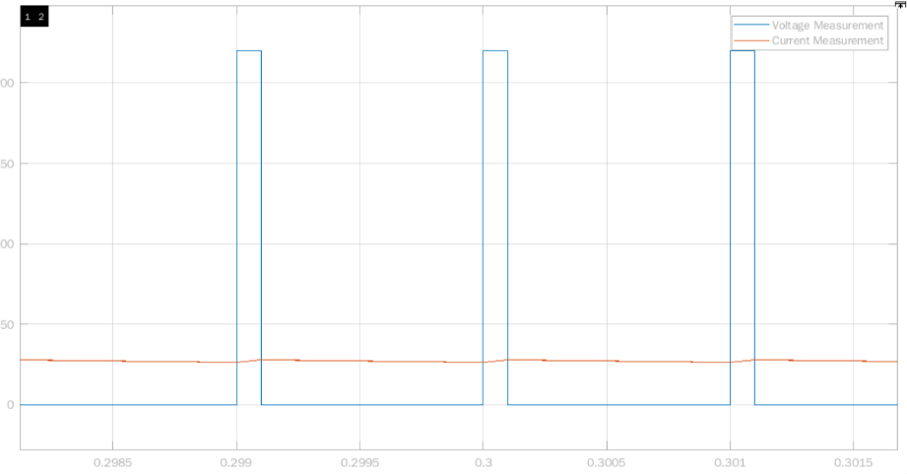

Figure 10. Output voltage (Va) and current waveforms (Ia) at D=0.1 in Simulink.

An average voltage of 20.87V and an average current of 27.12A was recorded on the DC motor for D=0.1. Indeed, this is close to the expected output, at DVin = 22V.

Providing a safety margin of +10%, the set of waveforms for D=0.1 place the following constraints:

|  |  |  |
| --- | --- | --- |
|  | Current rating | Voltage rating |
| IGBT | 3A | 210V |
| Freewheeling diode | 30A | -25V |

Table 2. IGBT and diode voltage and current limits for D=0.1 in Simulink.

It is expected that the IGBT current and diode voltage ratings will have to increase for the D=0.7 simulations, with the increase in the on-time of the circuit.,

With the duty increased to 70%, we will assume the motor has now sped up to its rated value of 1500rpm. For Ea, it was assumed that the constant term KaKfIf = 1, meaning Ea is simply the angular frequency counterpart of 1500rpm, at 157.08V.

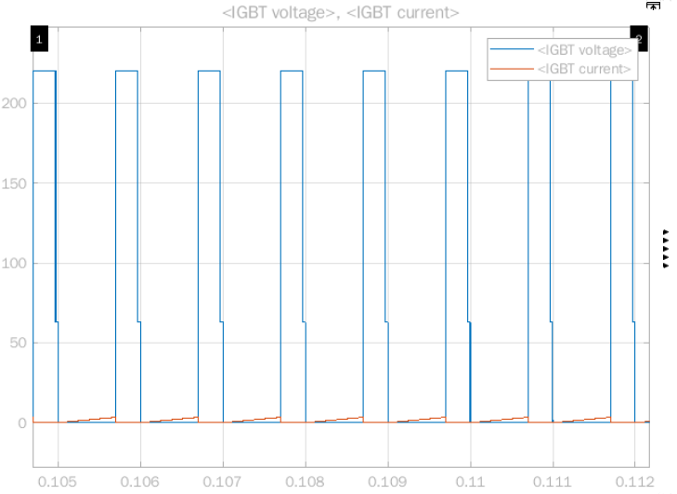

Figure 11. IGBT voltage and current waveforms at D=0.7 in Simulink.

An average voltage of 62.81V and an average current of 0.2552A was recorded on the IGBT for D=0.7. Considering Vin * (1-D) is 66V for this duty cycle, the IGBT diode voltage is a value we were expecting. This is because the IGBT voltage is zero during the on period (for an interval of DTs) of the buck converter, and nonzero otherwise.

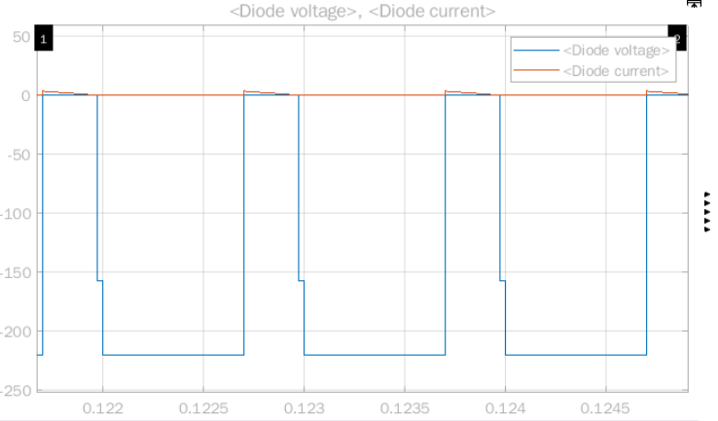

Figure 12. Freewheeling diode voltage and current waveforms at D=0.7 in Simulink.

An average voltage of –157.2V and an average current of 0.9553A was recorded on the freewheeling diode for D=0.7. Considering Vin * D is 154V for this duty cycle, the average diode voltage is a value we were expecting. This is because the diode voltage is only zero during the off period (for an interval of (1-D)Ts) of the buck converter, and negative otherwise (reverse-biased).

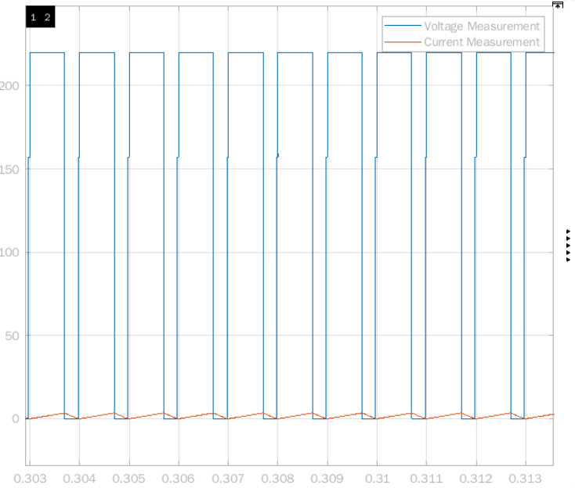

Figure 13. Output voltage (Va) and current waveforms (Ia) at D=0.7 in Simulink.

An average voltage of 157.2V and an average current of 1.687A was recorded on the DC motor for D=0.7. Indeed, this is close to the expected output, at DVin = 154V.

The set of waveforms for D=0.7 place the following constraints:

|  |  |  |
| --- | --- | --- |
|  | Current rating | Voltage rating |
| IGBT | 0.5A | 65V |
| Freewheeling diode | 1A | -160V |

Table 3. IGBT and diode voltage and current limits for D=0.7 in Simulink.

Presumably due to the assumption made on the motor emf constants, the armature current appears quite low. Naturally this affects the IGBT and diode currents. This seeming low current limit need not compromise our component selection, since the relatively worse-case scenario was already simulated for start-up conditions.

Taking the maximum ratings for the IGBT and the freewheeling diode for both of the simulated cases,

|  |  |  |
| --- | --- | --- |
|  | Current rating | Voltage rating |
| IGBT | 3A | 210V |
| Freewheeling diode | 30A | -160V |

Table 4. Anticipated IGBT and diode voltage and current limits.

## 555 Timer

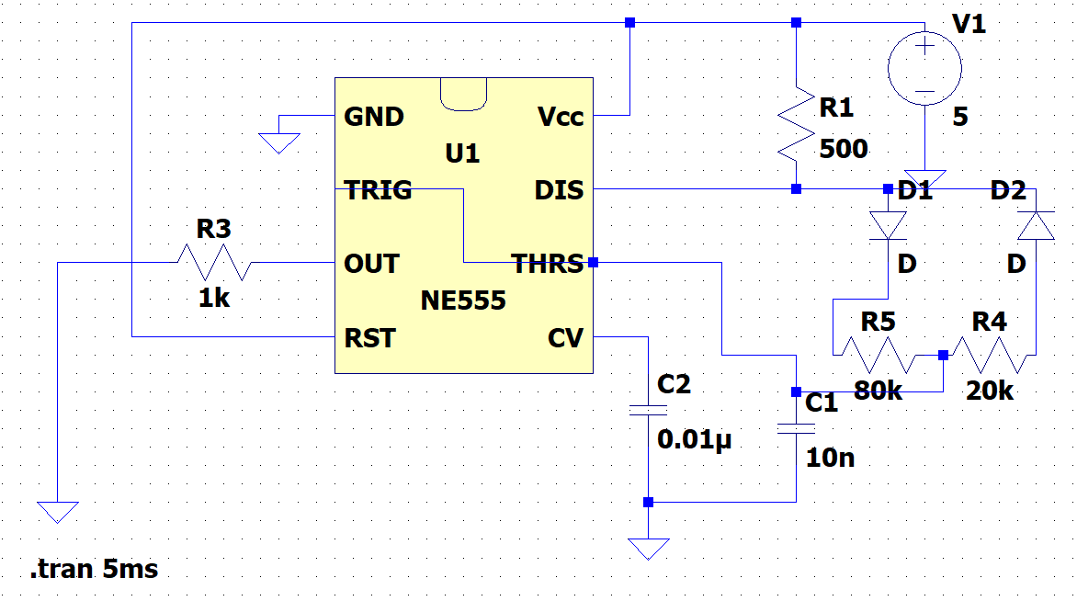

Figure 14. 555 Timer model in LTspice.

We have decided to use LM555 as a controller IC to drive the IGBT. This IC can produce constant frequency PWM signals when used in the configuration shown in Figure X. Here, R4 and R5 represents a potentiometer. Two diodes are necessary for constant frequency operation. As an input, 5V will be supplied to the IC. The capacitor connected to the Threshold pin (C1) and potentiometer determine the frequency of the PWM signal at the Output pin. Moreover, duty cycle is controlled by changing R5 and R4 ratio where D≈R5/(R4+R5) where R1 is comparatively small [1].

It is known that LC filter size can gets smaller as the frequency increases, however, we do not plan to use LC filter in our circuit since the load is a motor, which can be interpreted as an LCR combination. On the other hand, high frequency increases the switching losses of components such as diode or IGBT, which increases also heatsink size. So, it is decided to use 1kHz frequency considering high frequency losses. In this configuration, frequency formula is f≈1/[(R4+R5)*C1], so potentiometer value is selected as 100kΩ and capacitor is selected as 10nF, yielding 1kHz theoretically. However, this frequency is affected by other components and obtaining exactly 1kHz is not simple. Fortunately, this is not critical for our circuit considering frequency is obtained as 1.07kHz in the simulation which is a close value to the desired frequency. Output voltages are obtained as seen in Figure X, X, X for 3 different duty cycle, D=0.2, D=0.5 and D=0.8, and theoretical duty cycles and simulated duty cycles are very close.

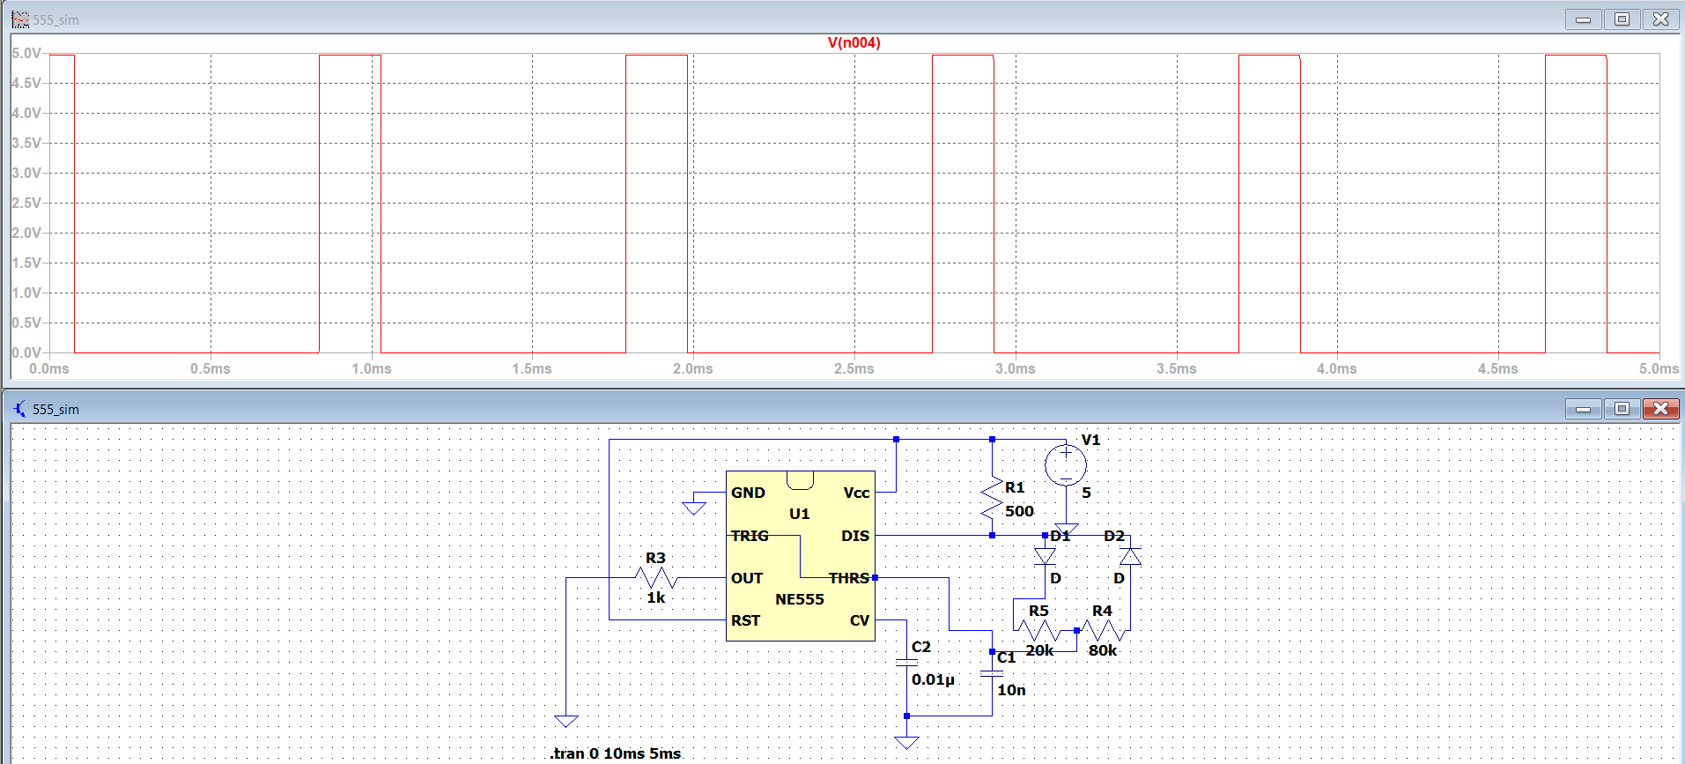

Figure 15. 555 Timer output voltage when D=0.2 in LTspice.

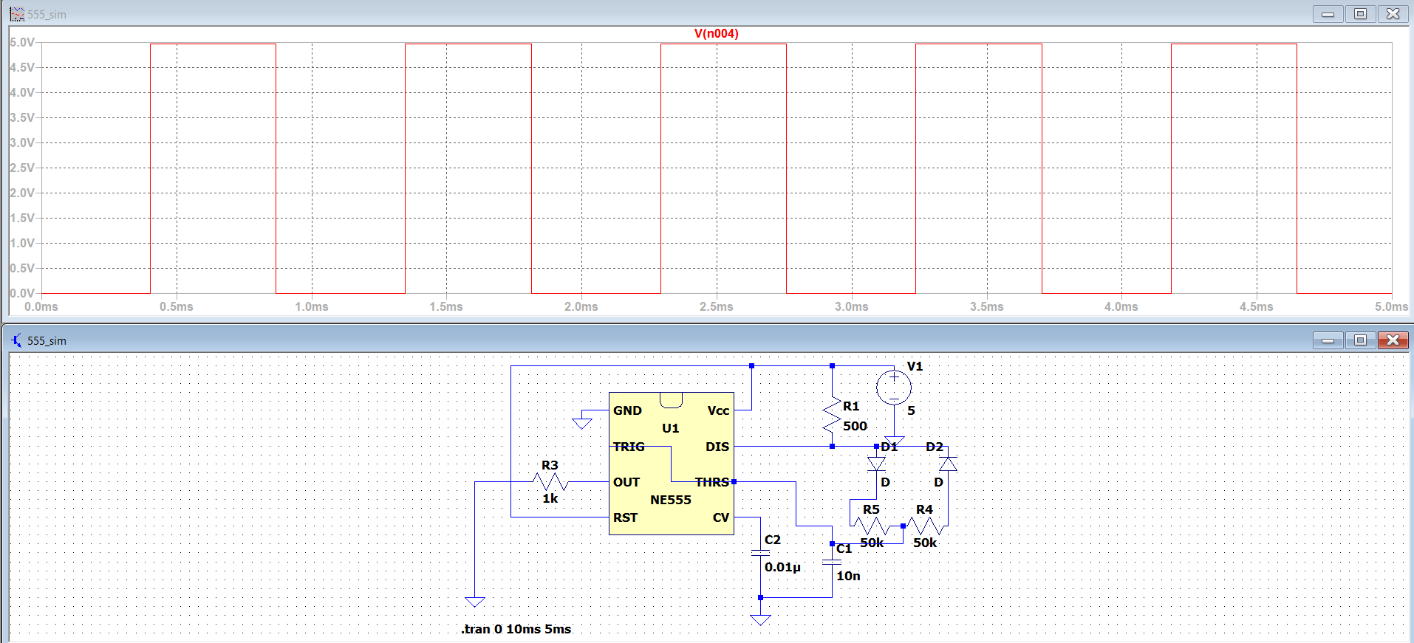

Figure 16. 555 Timer output voltage when D=0.5 in LTspice.

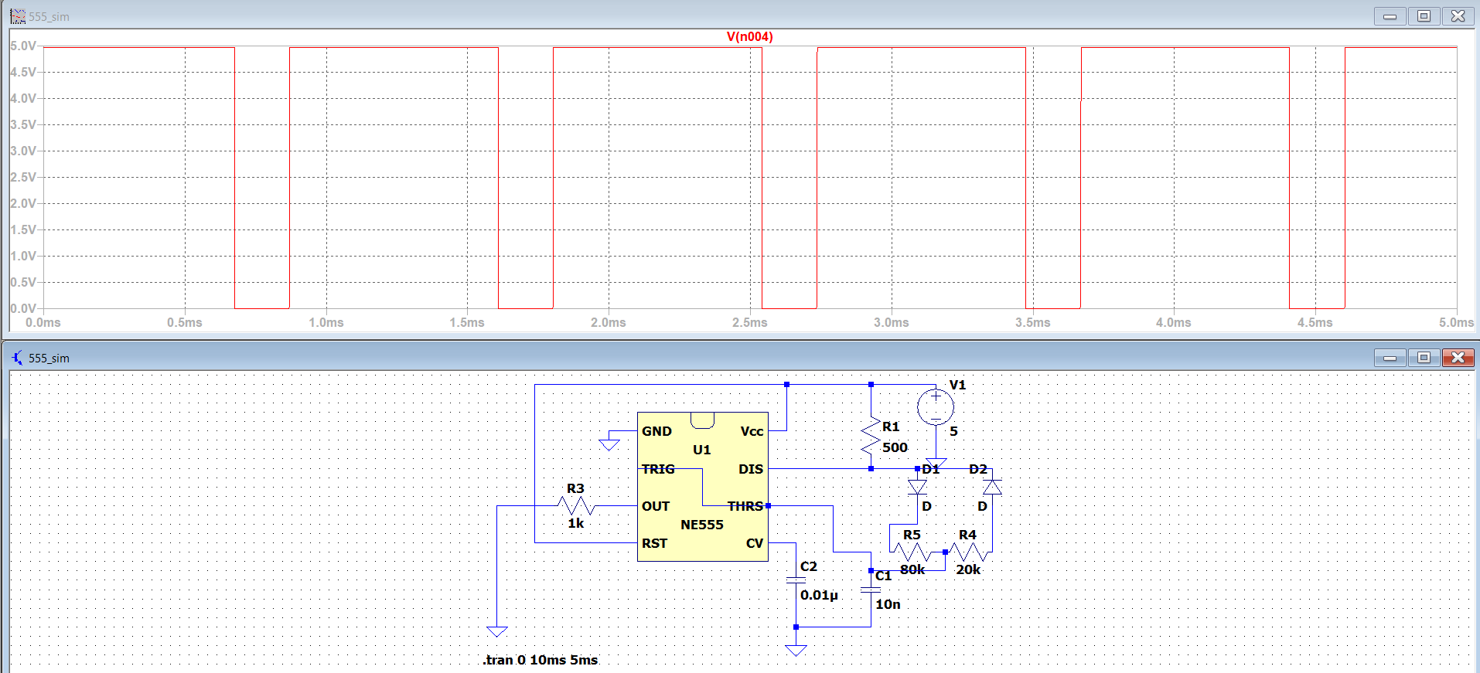

Figure 17. 555 Timer output voltage when D=0.8 in LTspice.

## Overall Circuit

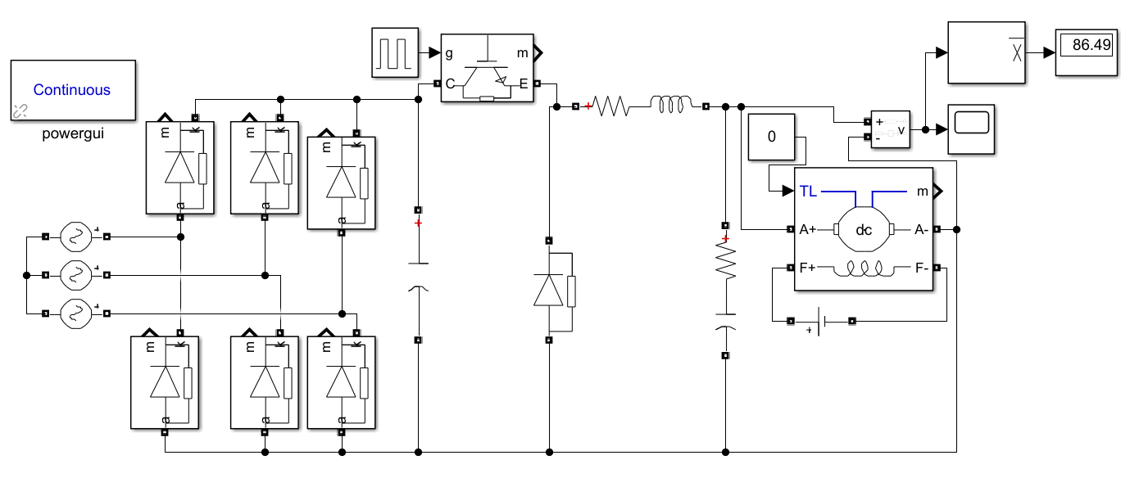

Figure 18. Overall Circuit Simulation Schematic.

With an input peak voltage of 200 volts, the almost ideal circuit simulated in MATLAB with hypothetical inductance and capacitance values gave us an average output of 86.5 volts with no load.

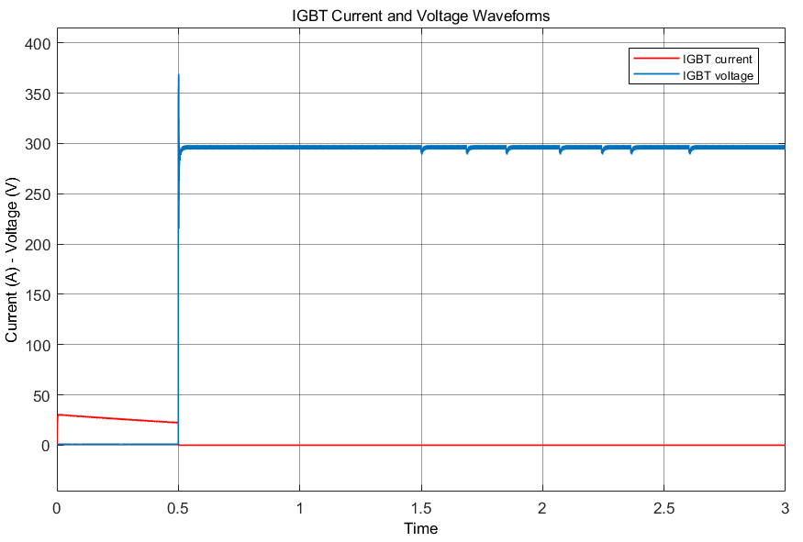

Figure 19. IGBT Current and Voltage.

The IGBT component that we use for switching created a meager current rating in the steady state, as seen previously, and component selections will be made accordingly.

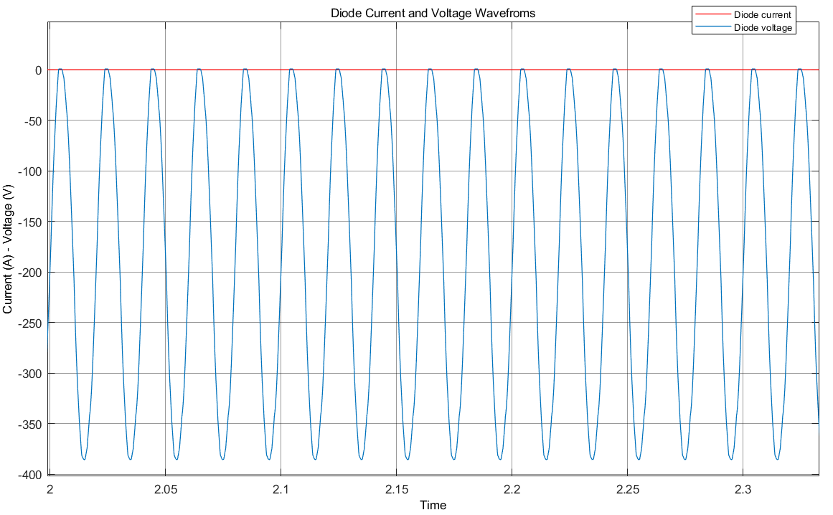

Figure 20. Diode Current and Voltage in SS.

Just like the IGBT diodes in the rectifier part have low current ratings as well. This will affect the component selection.

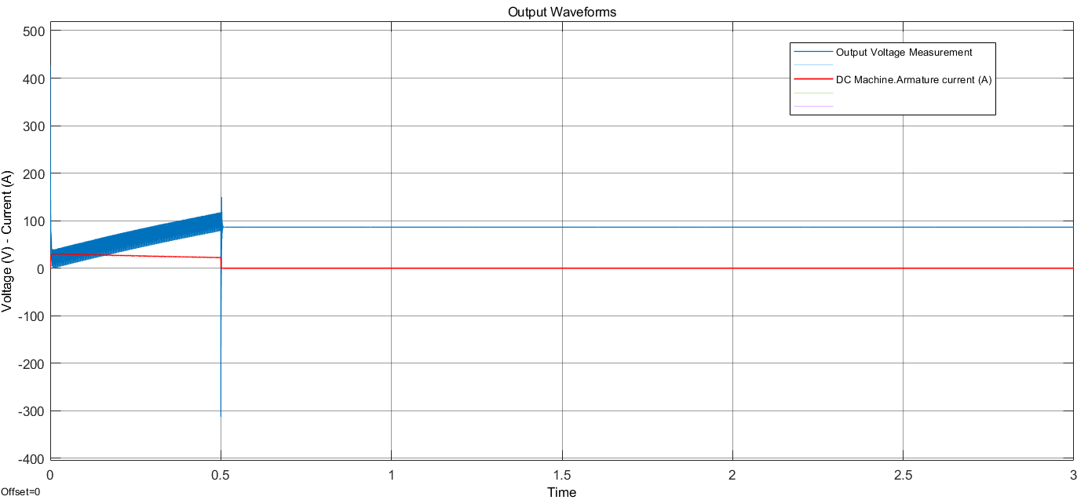

Figure 21. Output Voltage and Current of the 3PDR+Buck Topology.

# Component Selection

Generally, we have tried to choose components from the lab inventory since it is easier to replace them if a problem occurs. First, LM555 is chosen as PWM controller due to its simplicity. To isolate LM555 from the power side, optocoupler should be used and TLP250 isolated gate driver optocoupler is chosen for this purpose as it has sufficient isolation voltage for this application. To supply TLP250, 24V input will be given to it by the power supply in the lab. Also, that supply voltage is connected to ROE-2405S isolated DC/DC converter giving 5V isolated output which will supply LM555. By this method, usage of single power supply is accomplished.

In addition to these, transistor for the buck converter is chosen as IXGH24N60C4D1 according to the simulation results, which is an N-channel IGBT with 30A 600V rating. By simulation again, safe ratings of rectifier stage diodes and free-wheeling diode are around 30A 300V, hence, DSEP30-04A is selected as a diode, having 30A 400V rating. Three-phase bridge could also be used but in case of a problem, it would be easier to debug and replace single diodes.

Also, as explained in Simulations-Rectifier part, DC link capacitor is chosen as 470µF, resulting 4% ripple voltage in the simulation. 30A fuse can be added to the output of the rectifier. Moreover, the circuit will be constructed on a stripboard first, but it is planned to construct it on PCB, too.

# Thermal Analysis

# Implementation

So far, we have implemented the three-phase rectifier topology alongside its input ports without the output capacitor on a stripboard. Ohmic losses in this setup were quite high, to the point that one third of the expected average output voltage was already dissipated on the diodes and the solder iron connections or the electric wires. An example oscilloscope trace can be seen below.

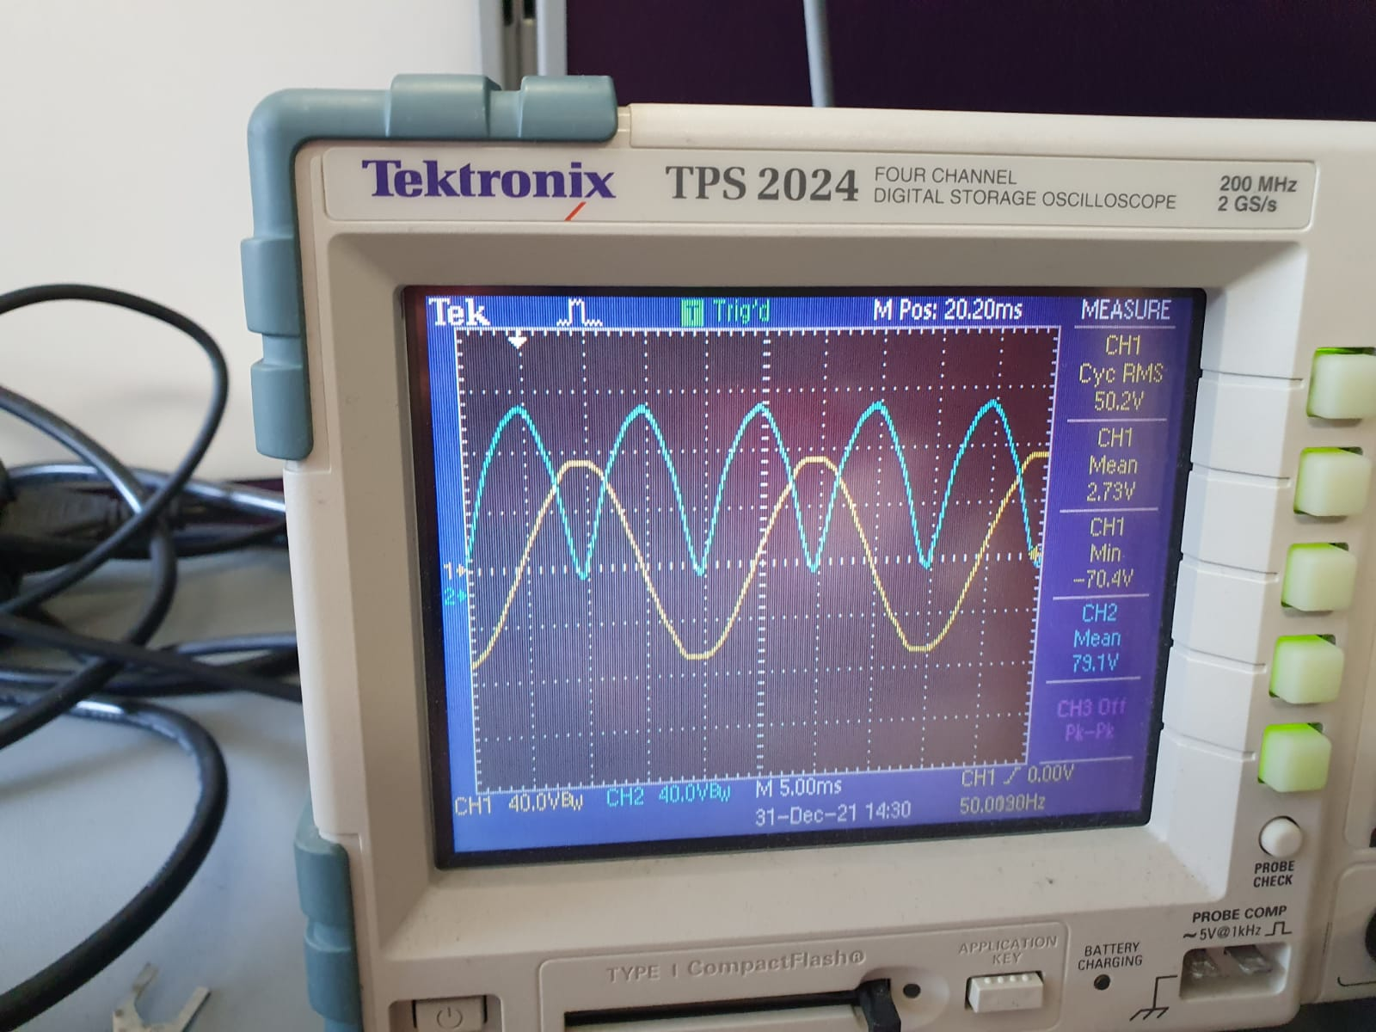

Figure x. Diode Rectifier Implementation Results.

This problem is expected to be solved upon the placement of the filter capacitor at the end. Should a single 470µF fail to decrease the ripple (and therefore increase the average voltage) to a desired and relatively steady value, another will be connected in parallel with it.

We will continue with the construction of the PWM generator circuit to drive the IGBT and the optocoupler topology. By using an isolated DC-DC converter to feed the 555 Timer and the optocoupler simultaneously, we will limit the required external DC power sources in the motor drive to a single supply.

Finally, we hope to complete the initial prototype of the circuit with the addition of an LC filter-deprived buck converter. A high side or low side drive method will be used in the IGBT activation. Depending on the verdict, the gate driver topology might change structurally.

# References

[1] 555 Timer IC: Introduction, Basics and Working with Different Operating Modes. <https://www.engineersgarage.com/555-timer-ic-introduction-basics-working-with-different-operating-modes/>